# CS 255 System Design Document Template

This template lays out all the different sections that you need to complete for Project Two. Each section has guidance to prompt your thinking. You will need to continually reference the interview transcript as you work to make sure that you are addressing your client’s needs. There is no required length for the final document. Instead the goal is to complete each section based on what your client’s needs are. Remove this note when you are finished, and replace all bracketed text with the relevant information.

## UML Diagrams

### UML Use Case Diagram

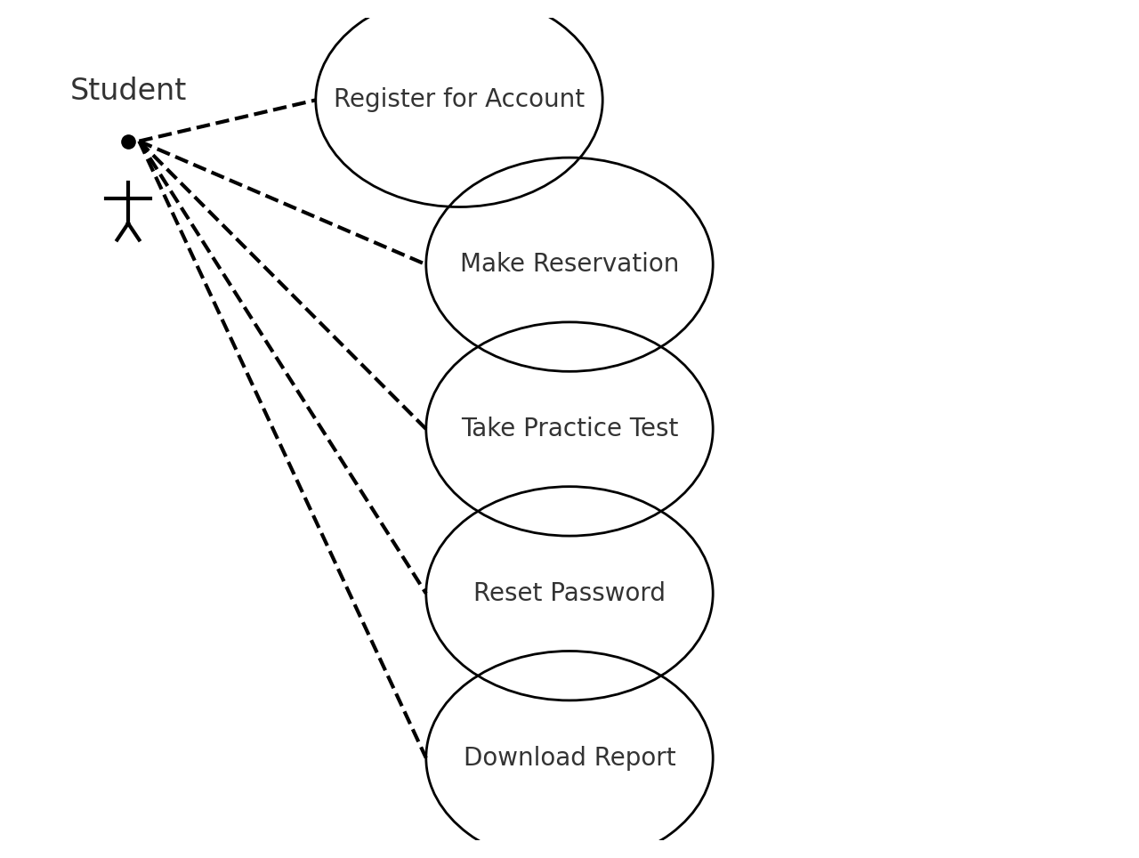

### UML Activity Diagrams

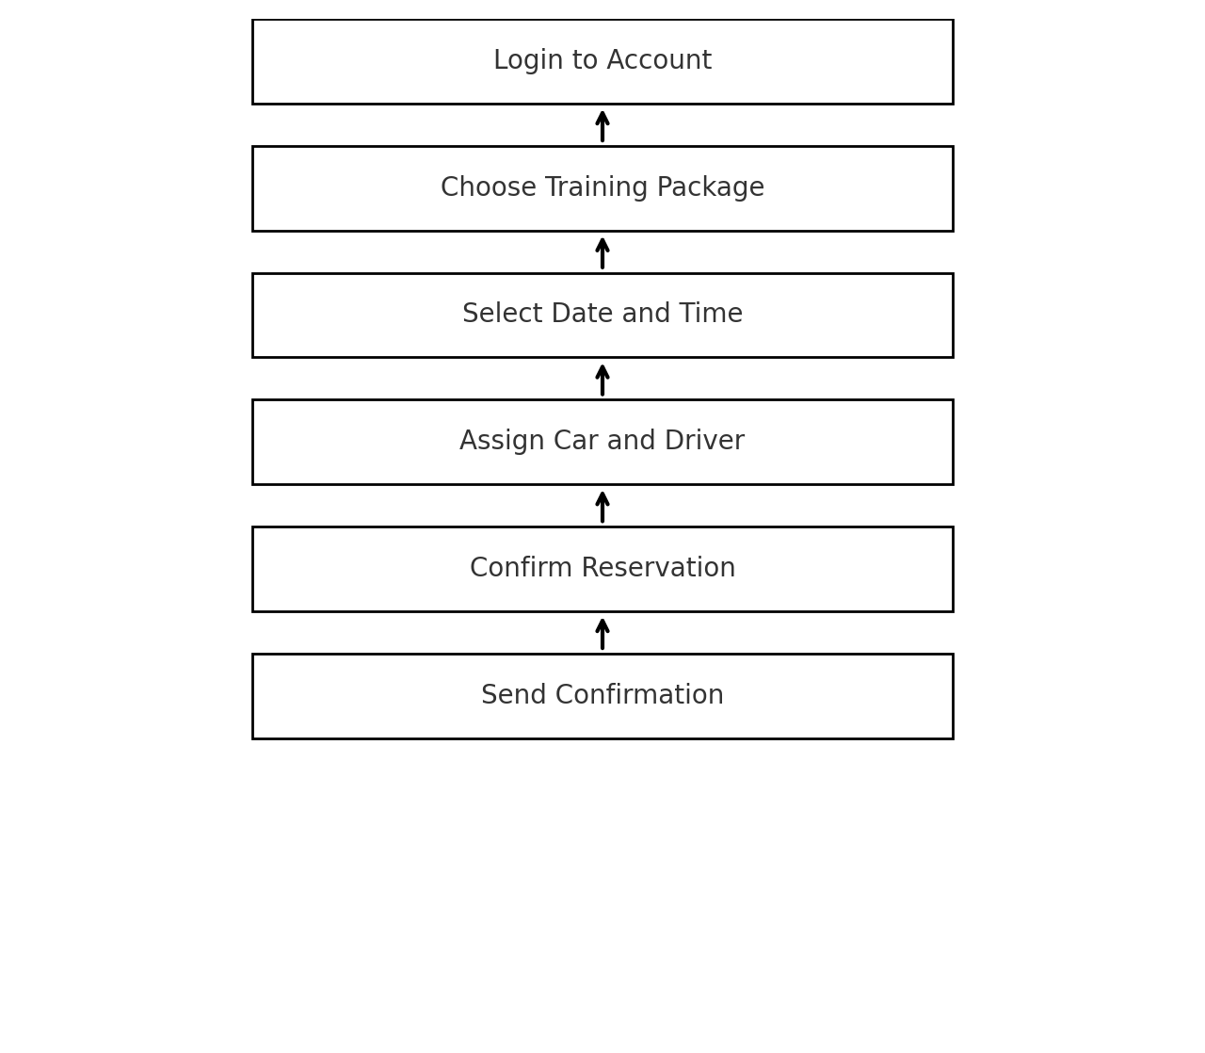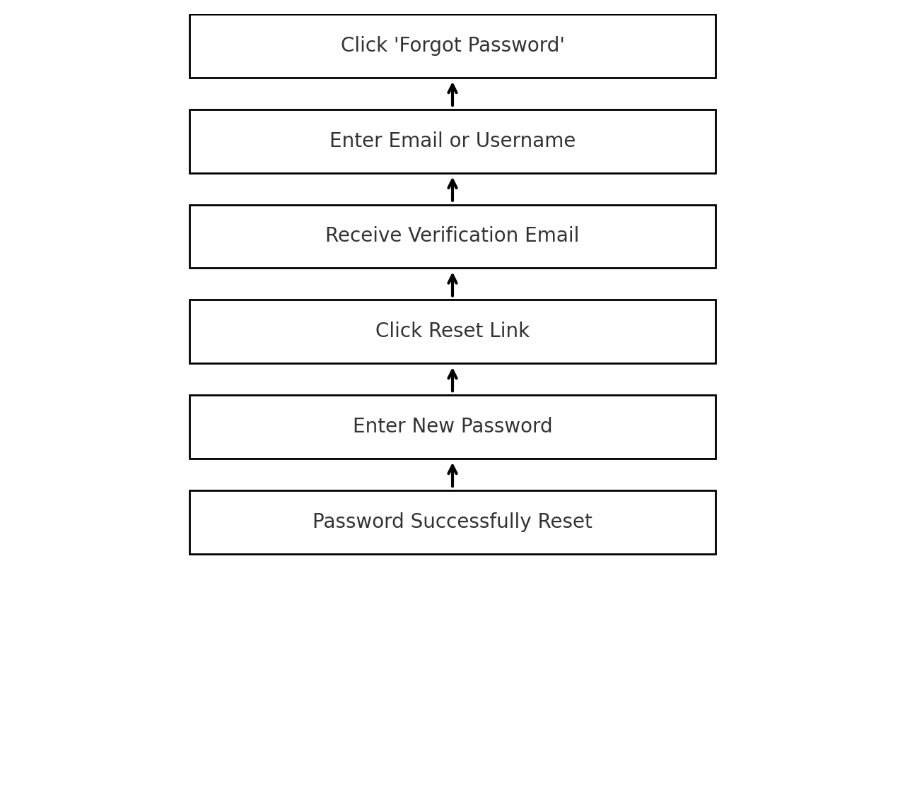

### UML Sequence Diagram

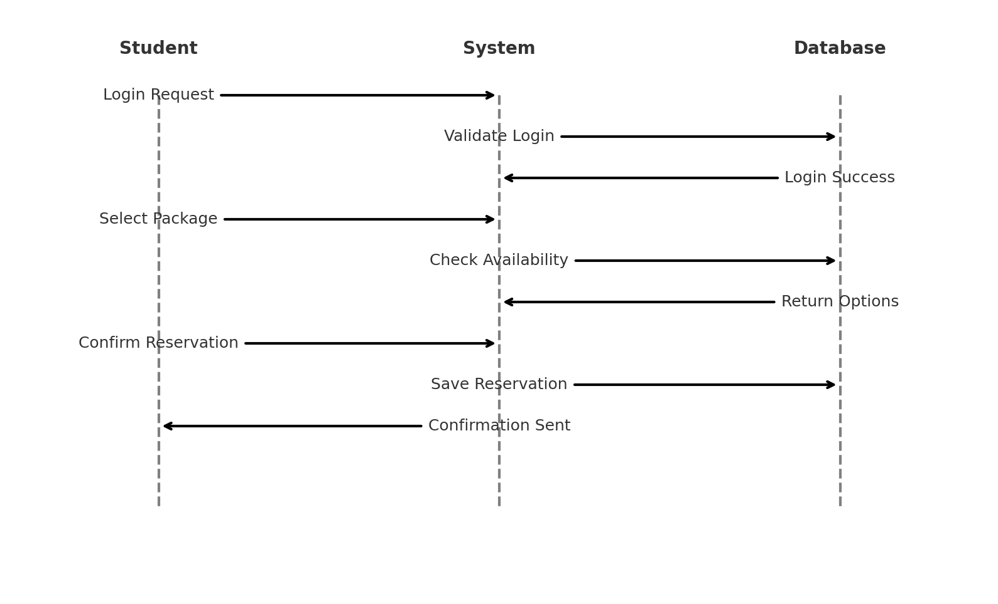

### UML Class Diagram

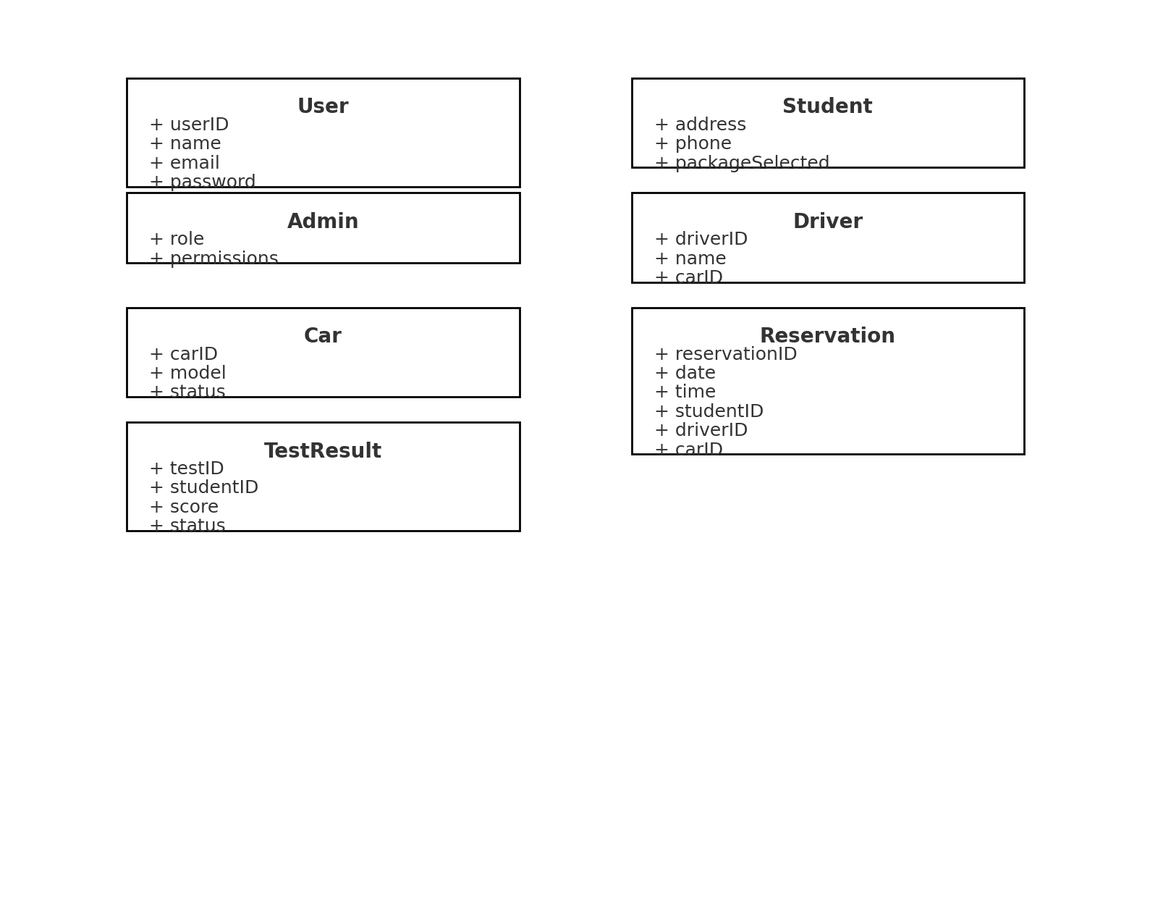

## The DriverPass system will be hosted in a cloud environment to ensure high availability and security. It requires a web-based interface accessible via both desktop and mobile devices. The infrastructure must support: - A secure login and role-based access control for students, admins, IT personnel, and secretaries - Cloud-hosted database storage with redundancy and automatic backups - Integration with email services for password resets and confirmations - Compatibility with Microsoft Excel for report exports - Tracking and activity logging with printable reports - Responsive design for UI, ensuring accessibility on multiple device types Software stack may include HTML/CSS/JS frontend, Python or Java backend, MySQL or PostgreSQL database, and AWS or Azure for deployment.

*[Based on the diagrams you have created, describe the technical requirements of your system. These requirements should address the required hardware, software, tools, and infrastructure necessary for your system design.]*





